**Java Web开发**

**实验八**

**作业报告**

|  |  |
| --- | --- |
| 学 院 | 计算机 |
| 所在系 班 级 | 2017软件工程系08班 |
| 学 号 姓 名 | 胡加劲 |
| 指 导 教 师 | 郭晓燕 |
| 完 成 时 间 | 2019年5月6日 |

# 实验题目

实验目标：

理解MVC模式的基本思想；

理解两种模型：模型1及模型

熟练掌握MVC模式的编程。

实验内容：

（必做）请用模型2MVC模式完成1个功能，功能自选，例如：登录、注册、发帖、计算税收等；

# 分析与设计

选择的功能为登陆与注册。运用mvc模式，分别在com.test8.bean中创建JavaBean文件，用来存放set与get方法，在com.test8.servlet中创建登录与注册的servlet文件，然后在项目中创建登陆与注册页面，以及注册和登录成功与失败的各个页面，并在web.xml中设定好路径，最后在数据库设定好test数据库和user表，并连接数据库。本实验使用的数据库版本和驱动为8.0，JDK版本为1.8。

# 关键源码（部分源代码）

Users.java

**package** com.test8.bean;

**public** **class** Users {

**private** Integer id;

**private** String name;

**private** String password;

**private** String role;

**public** Users() {

**super**();

// **TODO** Auto-generated constructor stub

}

**public** Integer getId() {

**return** id;

}

**public** **void** setId(Integer id) {

**this**.id = id;

}

**public** String getName() {

**return** name;

}

**public** **void** setName(String name) {

**this**.name = name;

}

**public** String getPassword() {

**return** password;

}

**public** **void** setPassword(String password) {

**this**.password = password;

}

**public** String getRole() {

**return** role;

}

**public** **void** setRole(String string) {

**this**.role = string;

}

}

UsersDAO.java

**package** com.test8.dao;

**import** java.sql.ResultSet;

**import** java.sql.DriverManager;

**import** java.sql.SQLException;

**import** java.sql.*;

**import** com.test8.bean.Users;

**public** **class** UsersDAO {

**public** **static** **final** String ***DBurl*** = "jdbc:mysql://localhost:3306/test?characterEncoding=utf8&useSSL=true&serverTimezone=UTC";

**public** **static** **final** String ***DBname*** = "com.mysql.jdbc.Driver";

**public** **static** **final** String ***DBuser*** = "root";

**public** **static** **final** String ***DBpassword*** = "1234567q";

**public** Users login(**int** id,String password) {

Users u = **null**;

Connection connection =**null**;

PreparedStatement pstmt=**null**;

ResultSet resultSet=**null**;

//赋值

**try** {

**try** {

Class.*forName*(***DBname***);//指定连接类型

connection = (Connection)DriverManager.*getConnection*(***DBurl***, ***DBuser***, ***DBpassword***);//获取连接

} **catch** (ClassNotFoundException e) {

e.printStackTrace();

}

//静态sql语句

String sql = "select * from user where id=? and password=?";

pstmt = (PreparedStatement) connection.prepareStatement(sql);

pstmt.setInt(1, id);

pstmt.setString(2, password);

resultSet = pstmt.executeQuery();

**if**(resultSet.next()){

u=**new** Users();

u.setId(resultSet.getInt("id"));

u.setName(resultSet.getString("name"));

u.setPassword(resultSet.getString("password"));

u.setRole(resultSet.getString("role"));

System.***out***.println("登录成功！");

}**else**{

System.***out***.println("用户名或者密码错误！");

}

} **catch** (SQLException e) {

e.printStackTrace();

}**finally** {

**if**(pstmt !=**null**){

**try** {

pstmt.close();

} **catch** (SQLException e) {

// **TODO** Auto-generated catch block

e.printStackTrace();

}

}

**if**(connection !=**null**){

**try** {

connection.close();

} **catch** (SQLException e) {

// **TODO** Auto-generated catch block

e.printStackTrace();

}

}

}

**return** u;

}

**public** **boolean** addUser(Users u) {

Connection connection = **null**;

PreparedStatement psmt = **null**;

**boolean** boo = **false**;

**try** {

**try** {

Class.*forName*(***DBname***);//指定连接类型

connection = (Connection)DriverManager.*getConnection*(***DBurl***, ***DBuser***, ***DBpassword***);//获取连接

} **catch** (ClassNotFoundException e) {

e.printStackTrace();

}

String sql ="insert into user(id,name,password,role)values(?,?,?,?);";

psmt = (PreparedStatement) connection.prepareStatement(sql);

//运用实体对象进行参数赋值

psmt.setInt(1, u.getId());

psmt.setString(2, u.getName());

psmt.setString(3,u.getPassword());

psmt.setString(4, u.getRole());

**int** result = psmt.executeUpdate();

**if**(result > 0){

boo = **true**;

System.***out***.println("插入数据成功");

}**else**{

System.***out***.println("未插入数据");

}

} **catch** (SQLException e) {

// **TODO** Auto-generated catch block

e.printStackTrace();

}**finally** {

**try** {

connection.close();

psmt.close();

} **catch** (SQLException e) {

e.printStackTrace();

}

}

**return** boo;

}

}

LoginServlet.java

**package** com.test8.servlet;

**import** java.io.IOException;

**import** javax.servlet.ServletException;

**import** javax.servlet.annotation.WebServlet;

**import** javax.servlet.http.HttpServlet;

**import** javax.servlet.http.HttpServletRequest;

**import** javax.servlet.http.HttpServletResponse;

**import** com.test8.bean.Users;

**import** com.test8.dao.UsersDAO;

**public** **class** LoginServlet **extends** HttpServlet {

**private** **static** **final** **long** ***serialVersionUID*** = 1L;

/**

* **@see** HttpServlet#HttpServlet()

*/

**public** LoginServlet() {

**super**();

// **TODO** Auto-generated constructor stub

}

/**

* **@see** HttpServlet#doGet(HttpServletRequest request, HttpServletResponse response)

*/

**protected** **void** doGet(HttpServletRequest request, HttpServletResponse response) **throws** ServletException, IOException {

doPost(request, response);

}

/**

* **@see** HttpServlet#doPost(HttpServletRequest request, HttpServletResponse response)

*/

**protected** **void** doPost(HttpServletRequest request, HttpServletResponse response) **throws** ServletException, IOException {

request.setCharacterEncoding("utf-8");

response.setContentType("text/html;charset=utf-8");

**int** id = Integer.*parseInt*(request.getParameter("id"));

String password = request.getParameter("password");

UsersDAO userDAO = **new** UsersDAO();

Users user = userDAO.login(id, password);

**if** (user != **null**) {

request.getRequestDispatcher("WEB-INF/pages/Lsuccess.jsp").forward(request, response);

} **else** {

request.getRequestDispatcher("WEB-INF/pages/Lerror.jsp").forward(request, response);

}

}

}

RegisterServlet.java

**package** com.test8.servlet;

**import** javax.servlet.ServletException;

**import** javax.servlet.annotation.WebServlet;

**import** javax.servlet.http.HttpServlet;

**import** javax.servlet.http.HttpServletRequest;

**import** javax.servlet.http.HttpServletResponse;

**import** java.io.IOException;

**import** com.test8.bean.Users;

**import** com.test8.dao.UsersDAO;

@WebServlet(name = "RegisterServlet")

**public** **class** RegisterServlet **extends** HttpServlet {

**protected** **void** doPost(HttpServletRequest request, HttpServletResponse response) **throws** ServletException, IOException {

request.setCharacterEncoding("utf-8");

response.setContentType("text/html;charset=utf-8");

**int** id = Integer.*parseInt*(request.getParameter("id"));

String name = request.getParameter("name");

String password = request.getParameter("password");

String role = request.getParameter("role");

Users u = **new** Users();

u.setId(id);

u.setName(name);

u.setPassword(password);

u.setRole(role);

UsersDAO userdao = **new** UsersDAO();

**boolean** boo = userdao.addUser(u);

**if** (boo == **true**) {

request.getRequestDispatcher("WEB-INF/pages/Rsuccess.jsp").forward(request, response);

} **else** {

request.getRequestDispatcher("WEB-INF/pages/Rerror.jsp").forward(request, response);

}

}

**protected** **void** doGet(HttpServletRequest request, HttpServletResponse response) **throws** ServletException, IOException {

doPost(request, response);

}

}

Index.jsp

<%@ page contentType=*"text/html;charset=UTF-8"* language=*"java"* %>

<html>

<head>

<title>主页</title>

</head>

<body>

<a href=*LoginPageServlet?url=WEB-INF/pages/Login.jsp*>登录页</a>

<a href=*RegisterPageServlet?url=WEB-INF/pages/Register.jsp*>注册页</a>

</body>

</html>

Login.jsp

<%@ page contentType=*"text/html;charset=UTF-8"* language=*"java"* %>

<html>

<head>

<title>登录页</title>

</head>

<div style="text-align:*center*;margin-top:*120px*">

<form action=*"LoginServlet"* method=*"post"*>

<table style="margin-left:*40%*">

<marquee width=*"200"*scrolldelay=*"250"*>用户登录</marquee>

<tr>

<td width=*"120"* height=*"40"*>登录id：</td>

<td colspan=*"2"*><input name=*"id"* type=*"text"* size=*"21"*></td>

</tr>

<tr>

<td width=*"120"* height=*"40"*>密码:</td>

<td colspan=*"2"*><input name=*"password"* type=*"password"* size=*"21"*></td>

</tr>

</table>

<br>

<input type=*"submit"* value=*"登录"*> &nbsp;&nbsp;

<input type=*"reset"* value=*"重置"*>

</form>

<br>

<a href=*RegisterPageServlet?url=WEB-INF/pages/Register.jsp*>注册页</a>

</div>

</body>

</html>

Register.jsp

<%@ page contentType=*"text/html;charset=UTF-8"* language=*"java"* %>

<html>

<head>

<title>注册页</title>

</head>

<body>

<div style="text-align:*center*;margin-top:*120px*">

<h1 >请注册</h1>

<form action=*"RegisterServlet"* method=*"post"*>

<table style="margin-left:*40%*">

<tr>

<td width=*"120"* height=*"40"*>ID:</td>

<td colspan=*"2"*><input name=*"id"* type=*"text"* size=*"20"*></td>

</tr>

<tr>

<td width=*"120"* height=*"40"*>登录名：</td>

<td colspan=*"2"*><input name=*"name"* type=*"text"* size=*"20"*></td>

</tr>

<tr>

<td width=*"120"* height=*"40"*>密码:</td>

<td colspan=*"2"*><input name=*"password"* type=*"password"* size=*"20"*></td>

</tr>

<tr>

<td width=*"120"* height=*"40"*>用户类别：</td>

<td colspan=*"2"*><select name=*"role"* type=*"text"* size=*"1"*>

<option>学生</option>

<option>教师</option>

<option>管理员</option>

</select>

</tr>

</table>

<br>

<input type=*"submit"* value=*"注册"*> &nbsp;&nbsp;

<input type=*"reset"* value=*"重置"*>

</form>

<br>

<a href=*LoginPageServlet?url=WEB-INF/pages/Login.jsp*>登录页</a>

</div>

</body>

</html>

# 运行效果图

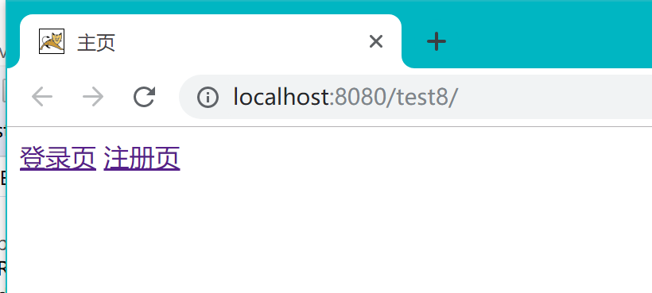

初始页面

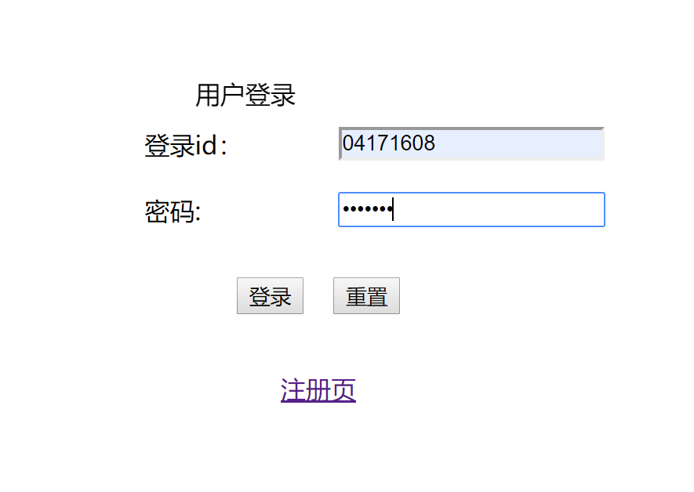

登录页面

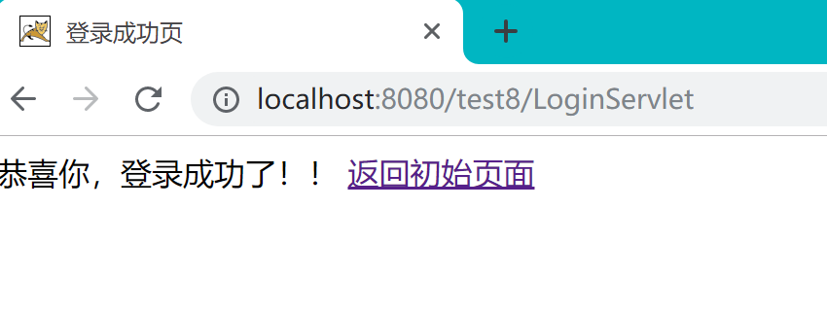

登陆成功

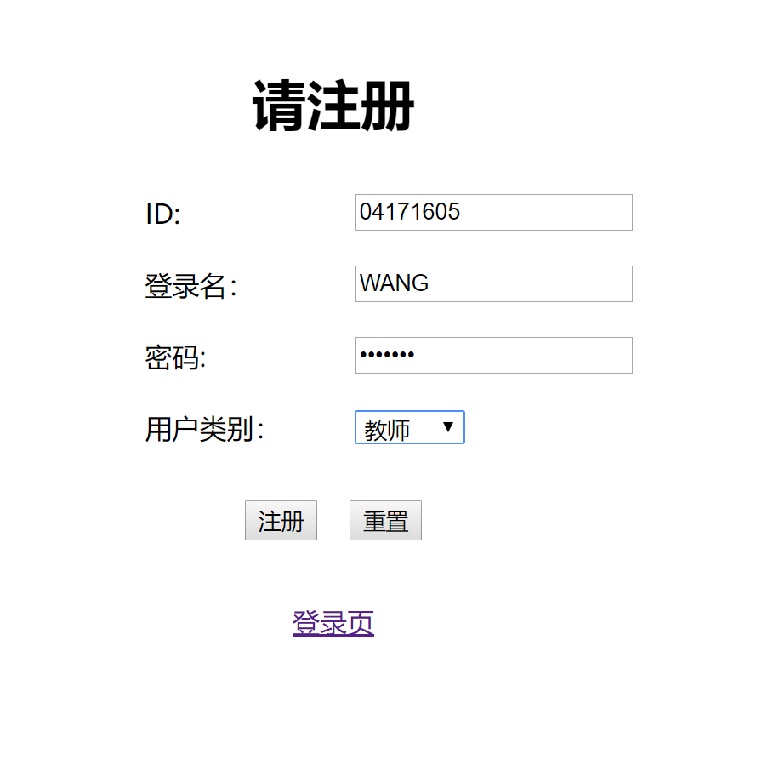

注册界面

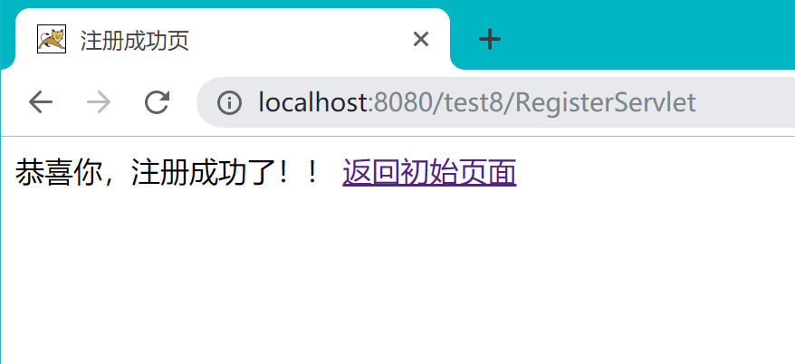

注册成功

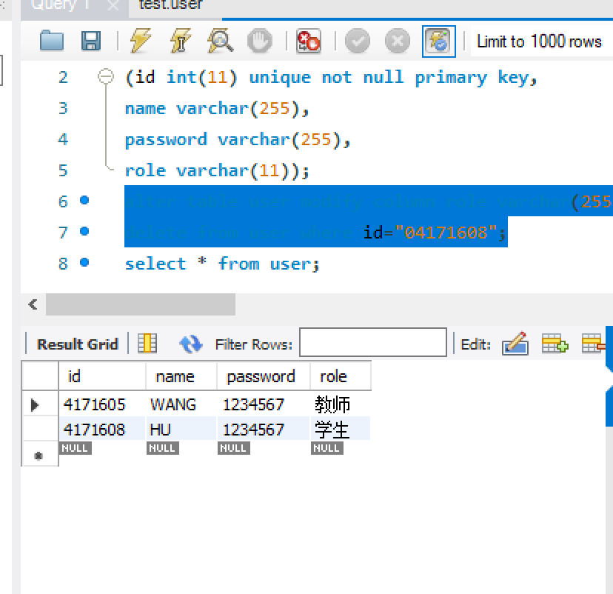

数据库页面

# 收获与问题

了解如何使用JDBC驱动并连接数据库，了解MVC模式的应用